|  |
| --- |
| Group Informatics  User Manual |
| [Clinical Research Metrics Dashboard] |
| Document ID: UserManual_Clinical_Research_Metrics_Dashboard_V1.0.0  Version: 1.0.0  Effective Date: Date of last signature  PMM Template Version: 8.0 [February 2014] |

Document Information

|  |  |
| --- | --- |
| **Project Name** | Clinical Research Metrics Dashboard |
| **Document Name** | User Manual |
| **Solution Owner** | Michael Zhang |
| **Document Location** |  |
| **Associated Documents** |  |

Author

| **Role** | **Name** | **Dept.** | **Signature** | **Date** |
| --- | --- | --- | --- | --- |
| Author | Tony Gu | Informatics |  | |

Review

| **Role** | **Name** | **Dept.** | **Signature** | **Date** |
| --- | --- | --- | --- | --- |
| Project Manager | Kelly Tao | Informatics |  | |

Approval

| **Role** | **Name** | **Dept.** | **Signature** | **Date** |
| --- | --- | --- | --- | --- |
| Business Lead | Tina Yin | Medical |  | |

Document History

| **Version** | **Changes** | **Effective Date** |
| --- | --- | --- |
| 1.0 | First Approved version | Date of last signature |

Table of Contents Page

1. Purpose 5

2. Definitions 5

3. Operation: Admin 5

3.1 Add CPL or LM users 5

3.2 Remove CPL or LM users 7

3.3 Assign New Incoming Study to CPL 8

4. Operation: CPL 8

4.1 Access Home Page 8

4.1.1 Milestone Summary by Study 8

4.1.2 Monthly Step Count/ Median Step During 9

4.1.3 Study Milestone details 9

4.1.4 Study Summary by Status 9

4.1.5 Study Summary by GPS 10

4.1.6 Study Summary by DA 10

4.1.7 Study Summary by Interventional 11

4.1.8 Site Activation 11

4.1.9 Recruitment 11

4.1.10 ICF 12

4.1.11 Issue Log 12

4.1.12 Trial Monitor 13

4.1.13 CRF 13

4.1.14 Safety Reference 13

4.2 Overview Page 14

4.2.1 General information 14

4.2.2 Country Timeline 14

4.2.3 Site Timeline Median Duration 15

4.2.4 Recruitment 15

4.2.5 Issue log 16

4.2.6 Trial Monitoring 16

4.2.7 Safety Reference 17

4.2.8 CRF 17

4.2.9 Site Activation 18

4.2.10 ICF 18

4.3 Time Line 19

4.3.1 Country Time Line 19

4.3.2 Site Time Line 19

4.4 SMT Chart 21

4.5 Issue Log 22

4.6 Case Report Form 24

4.7 Trial Monitoring 25

4.8 Site Activation 27

4.9 Safety Reference 27

4.10 ICF 29

4.11 Recruitment 31

4.11.1 Country Recruitment 31

4.11.2 Site Recruitment 33

5. Operation: LM 34

5.1 Access Home Page 34

5.1.1 Milestone Summary by Study 34

5.1.2 Monthly Step Count/ Median Step During 34

5.1.3 Study Milestone details 35

5.1.4 Study Summary by Status 35

5.1.5 Study Summary by GPS 35

5.1.6 Study Summary by DA 36

5.1.7 Study Summary by Interventional 36

5.1.8 Site Activation 37

5.1.9 Recruitment 37

5.1.10 ICF 37

5.1.11 Issue Log 38

5.1.12 Trial Monitor 38

5.1.13 CRF 38

5.1.14 Safety Reference 39

5.2 Overview Page 39

5.2.1 General information 40

5.2.2 Country Timeline 40

5.2.3 Site Timeline Median Duration 40

5.2.4 Recruitment 41

5.2.5 Issue log 41

5.2.6 Trial Monitoring 41

5.2.7 Safety Reference 42

5.2.8 CRF 42

5.2.9 Site Activation 43

5.2.10 ICF 43

5.3 Time Line 44

5.3.1 Country Time Line 44

5.3.2 Site Time Line 44

5.4 SMT Chart 46

5.5 Issue Log 47

5.6 Case Report Form 49

5.7 Trial Monitoring 50

5.8 Site Activation 51

5.9 Safety Reference 52

5.10 ICF 54

5.11 Recruitment 56

5.11.1 Country Recruitment 56

5.11.2 Site Recruitment 58

# Purpose

The purpose of this document is to introduce functionality that has provided in the system and instruct users using that functionality properly and effectively.

# Definitions

The following terms and abbreviations are used in this document:

| **Term** | **Definition** |
| --- | --- |
| LM | Line Manager |
| CPL | Clinical Project Leader |
| Admin | Administrator |
|  |  |

# Operation: Admin

System administrator can maintain permission of CPL, LM to the Clinical Research Metrics Dashboard.

## Add CPL or LM users

1. Access Administration address:  
   <http://spdeweb01.shp.roche.com/sites/StudyPortal/SitePages/Forms/AllPages.aspx>
2. Click on "Site Actions" on the top of left, then click on “Site Permission”

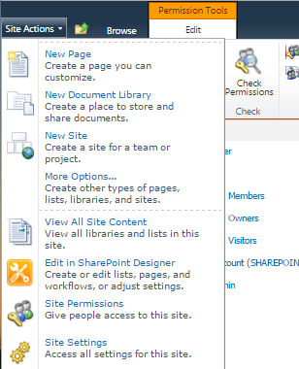

1. Click on “PL” or “LM” to access “PL” or “LM” group

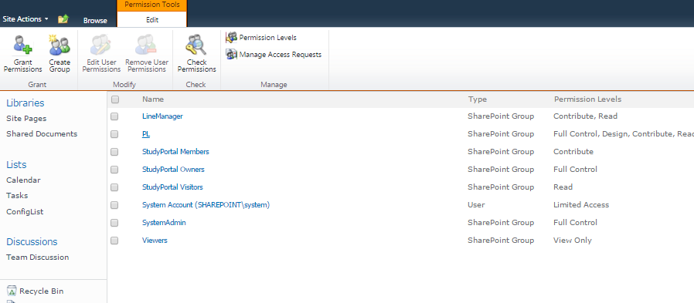

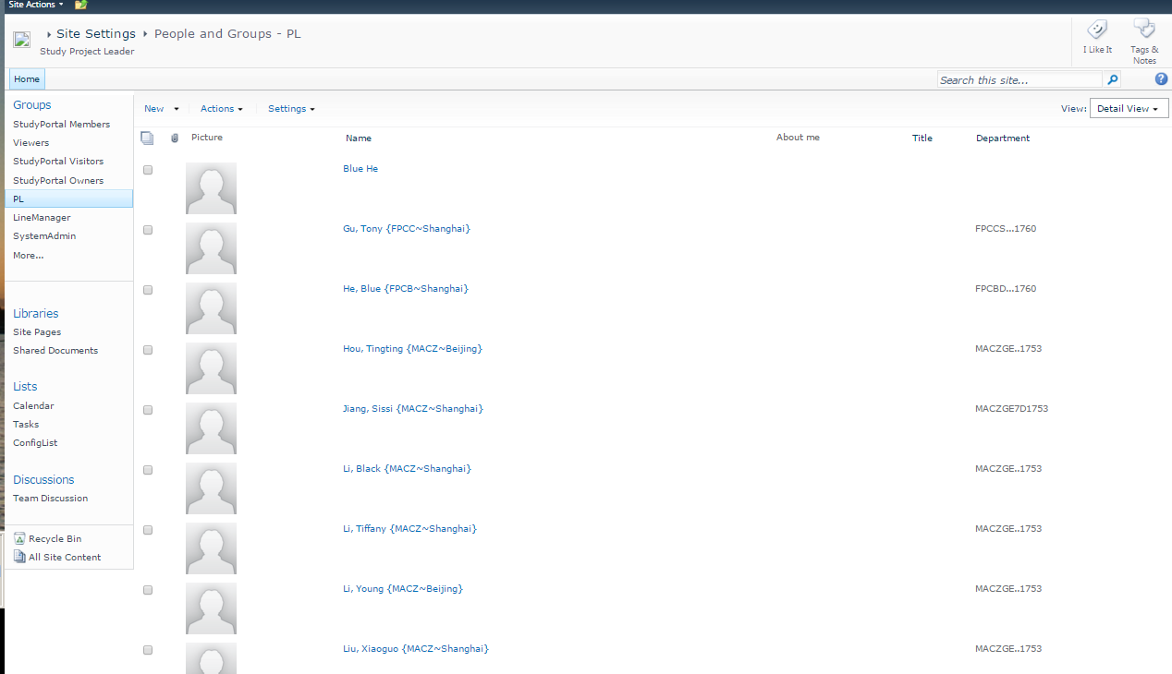

1. Click “New”, click “add users”

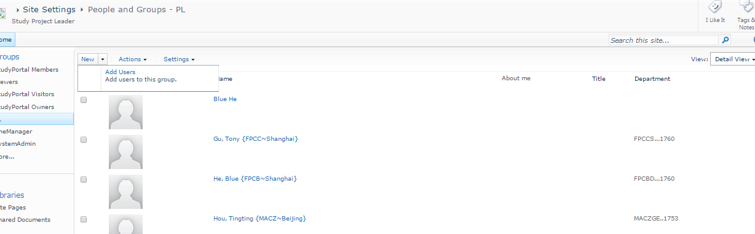

1. Click on “bookmark”, In “Find” area, input userid, click on “search” button on the right, Select “Account Name” as started with “RMOASIA\”.  
   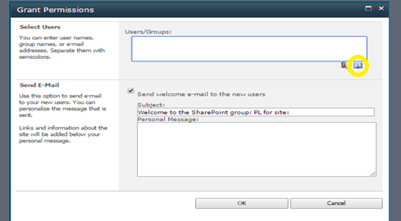

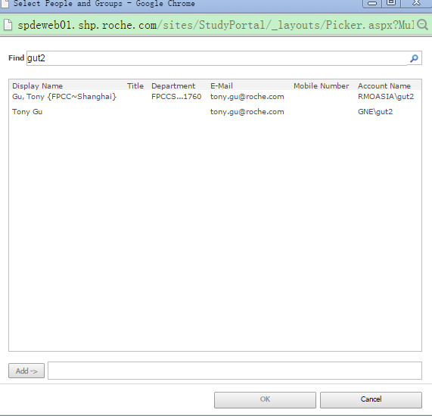

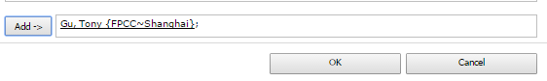

1. Click “Add” button, click “OK” button.

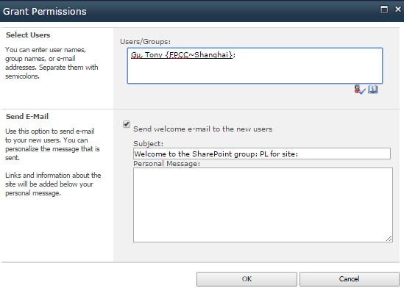

## Remove CPL or LM users

1. Repeat Step 1-3 in Add users.
2. Select a user, click on Actions, then click “Remove users from group”

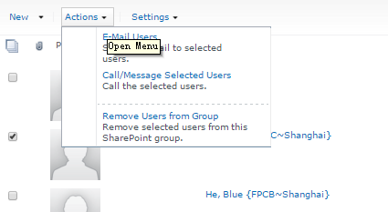

## Assign New Incoming Study to CPL

If there is a new incoming study detected from CTMS, Clinical Research Metrics Dashboard system will send notification mail to portal administrator, administrator should assign this new study to a responsible CPL.

1. Access study link in notification mail, and access SMT Chart page.
2. Click “Add” button to add responsible CPL.
3. Click “save” to save changes.

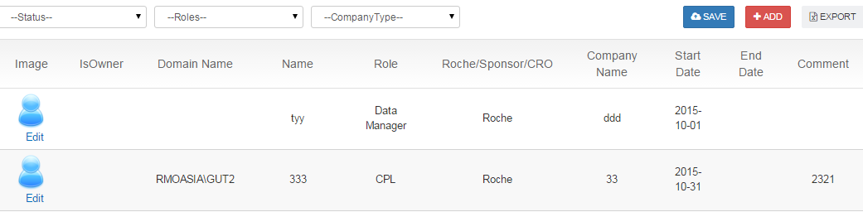

**Note**: IsOwner means CPL member who is in charge of new study, change the value to “Yes”, and input the “Domain Name” as “RMOASIA\userid”(ex, RMOASIA\GUT2)

# Operation: CPL

CPL (Clinical Project Leader) can maintain assigned studies information on Clinical Research Metrics Dashboard.

## Access Home Page

On Home Page, CPL can see assigned studies summary.

http://spdeweb01.shp.roche.com/sites/StudyPortal/SitePages/HomePage.aspx

### Milestone Summary by Study

Display duration between two consecutive Milestones

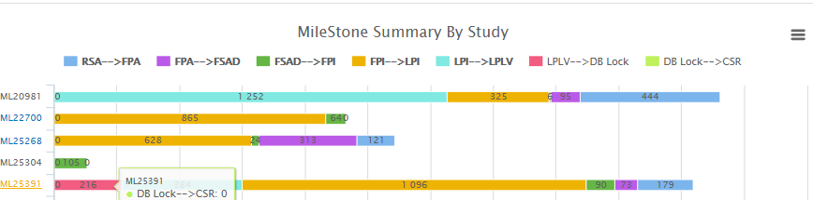

### Monthly Step Count/ Median Step During

1. Planning count (Reporting Month), Actual count (Reporting Month), Ahead count(YTD) is counts of Actual date < Planned date at each milestone level.

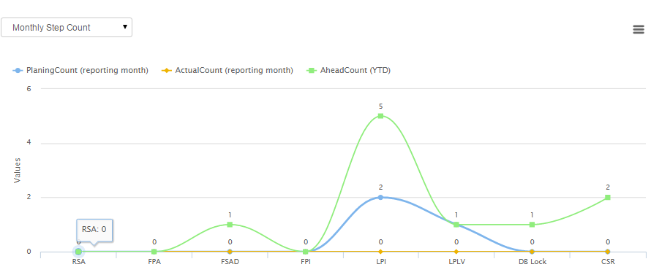

1. Click on arrow to view Median Step During, which means the median duration days between two consecutive milestone

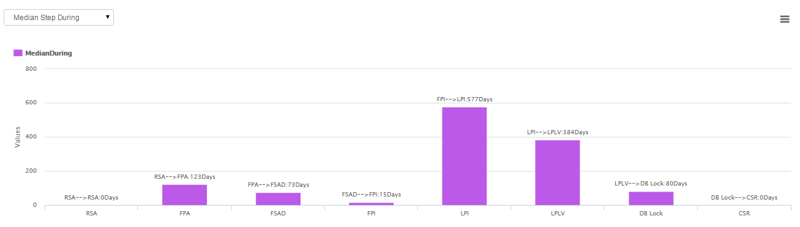

### Study Milestone details

Display Study Milestone details, If Actual date <= Planned date, marked in green, If Actual date > Planned date, marked in red

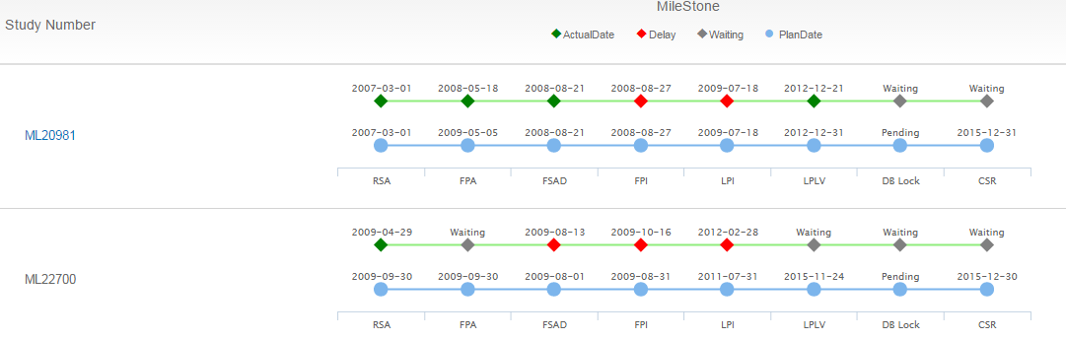

### Study Summary by Status

Display counts of Study by different status and priority.

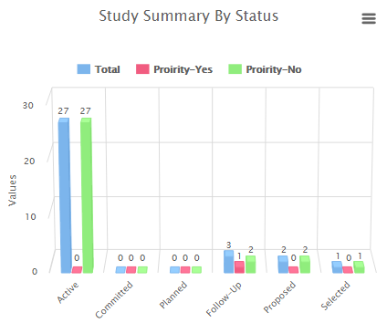

### Study Summary by GPS

Display counts of Study by GPS

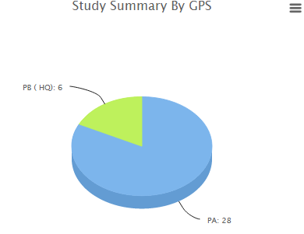

### Study Summary by DA

Display counts of Study by DA

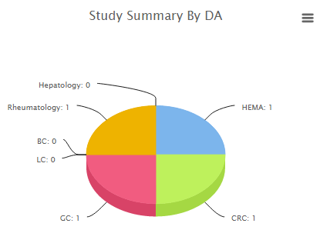

### Study Summary by Interventional

Display counts of Study by Interventional

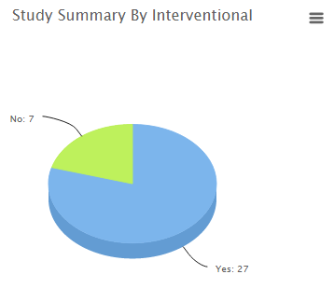

### Site Activation

Display % of correctly activated sites per month.

Formula: Corrected active sites/total activated sites

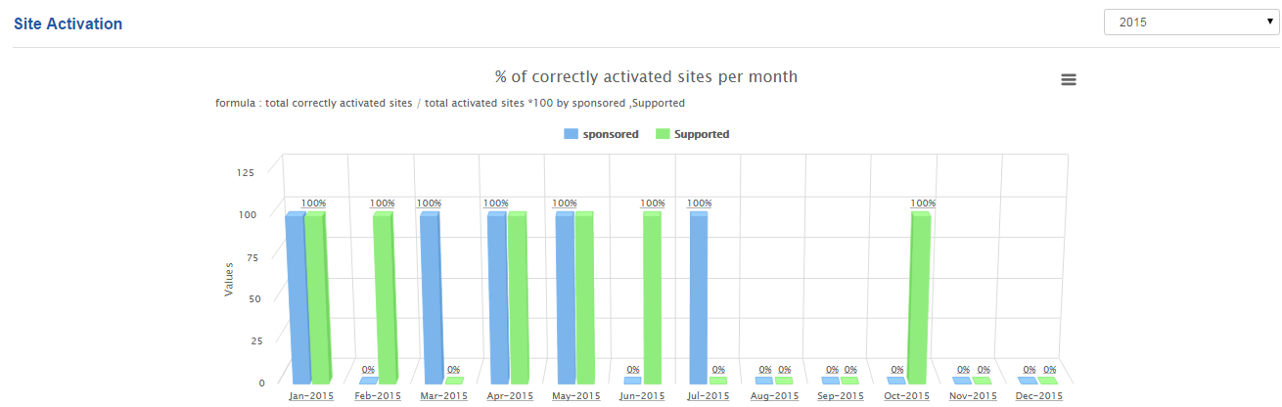

### Recruitment

Display Enrollment Speed by Study

Formula:

% enrollment speed: Cumulative Actual/Cumulative Planning

% enrollment (total):SCNTR_ACTUALNUMENROLLED/PLANNEDNUMENROLLED

% low enrollment site: Low percent counts of site /Total counts

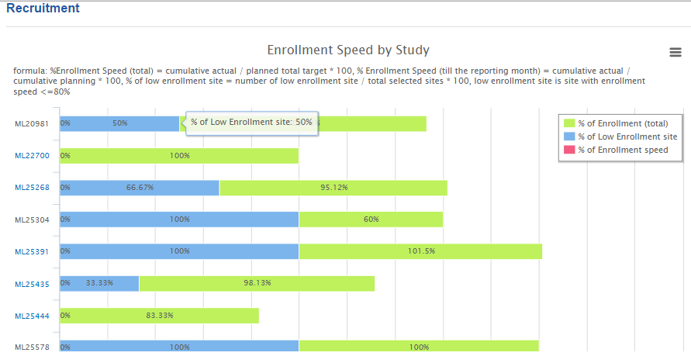

### ICF

Display % of correctly approved ICFs

Formula: Correctly approved ICFs/total ICFs

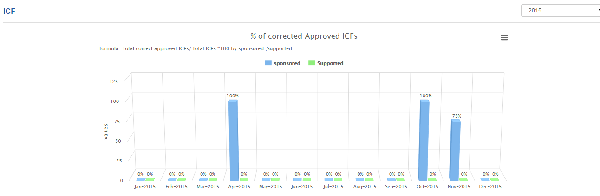

### Issue Log

Display % of delayed issues per month

Formula: Delayed issues/Total issues

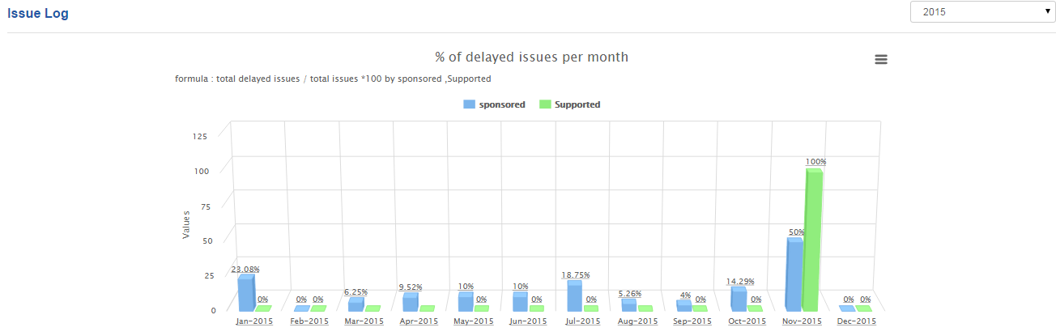

### Trial Monitor

Display % SMR submission delayed and % SMR review delayed per month

Formula: SMRReviewDelay=DelaySToRCount/TotalCount

SMRSubmissiondelay=DelayCToSCount/TotalCount

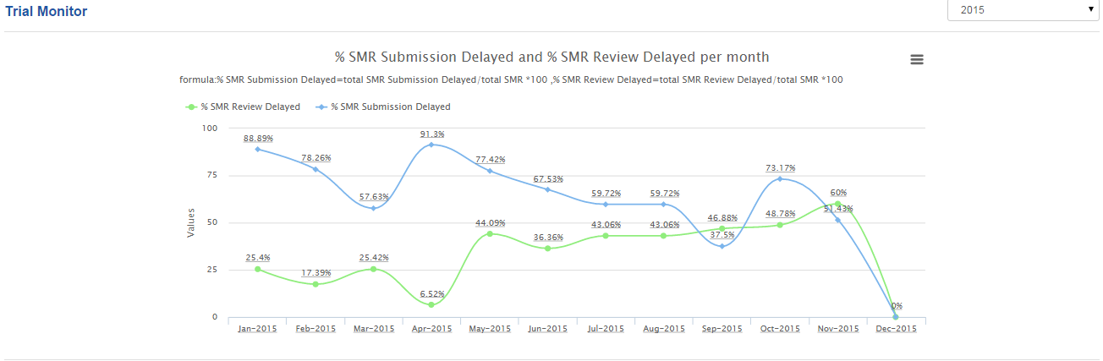

### CRF

Display # missing data/1000(reporting month), # discrepancy data/1000(reporting month), CRF completion %

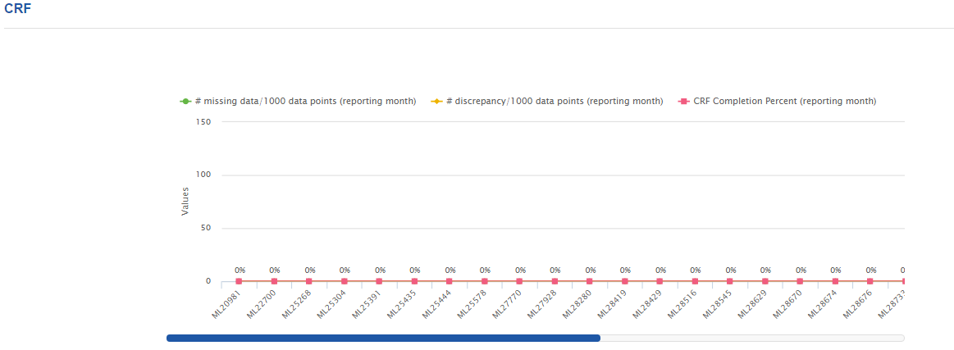

### Safety Reference

Display % of late received and % of not accessed per month

Formula: 1) % of "Not Accessed" for each site = number of "not accessed" / number of all documents (removed document is excluded).

2) % of late received for each site = number of late received document / number of all documents, late received means the time between the "date document was first accessed by the site" and "document upload date" is larger than 14 calendar days.

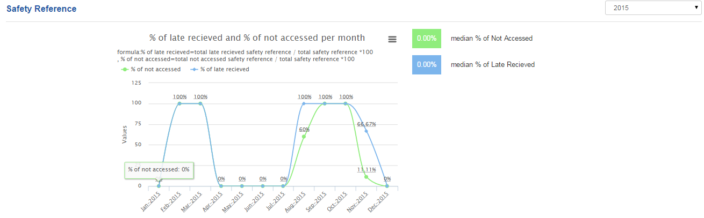

## Overview Page

Overview page display single detailed study information, CPL can check /uncheck filter to display relevant information.

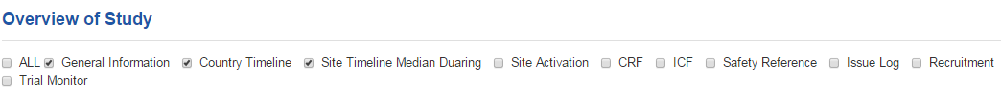

### General information

Display General Information for current study, user can maintain “DA”, “Priority” area if necessary, and click save to save changes.

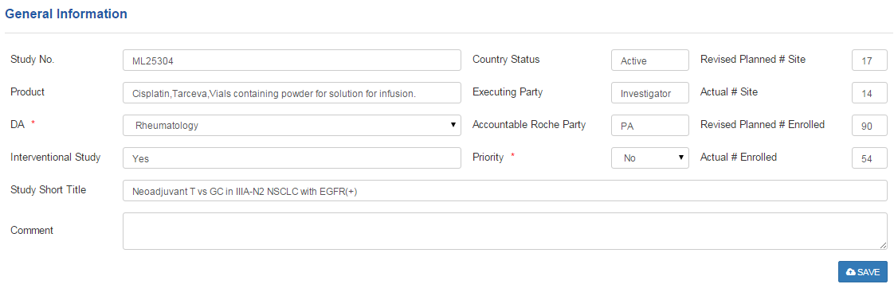

### Country Timeline

Display current study of Country Milestone

Formula:   
Cycle Time=duration days between two consecutive milestones, If actual date > planned date, highlight the milestone with red.

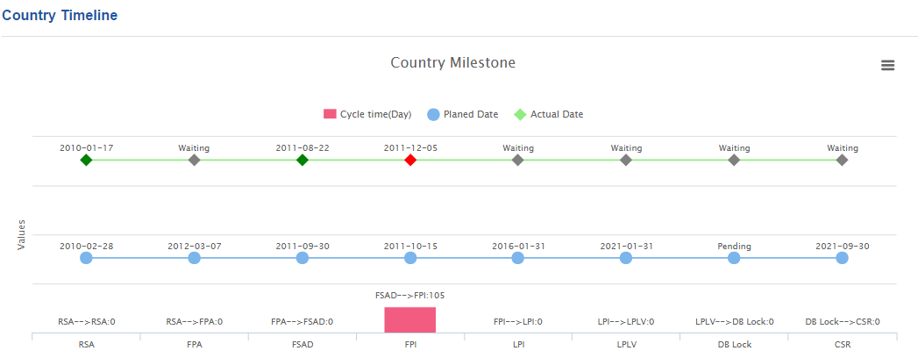

### Site Timeline Median Duration

Display current study of Cycle time between selected milestones at each site.

Formula:

Duration days between two consecutive milestones

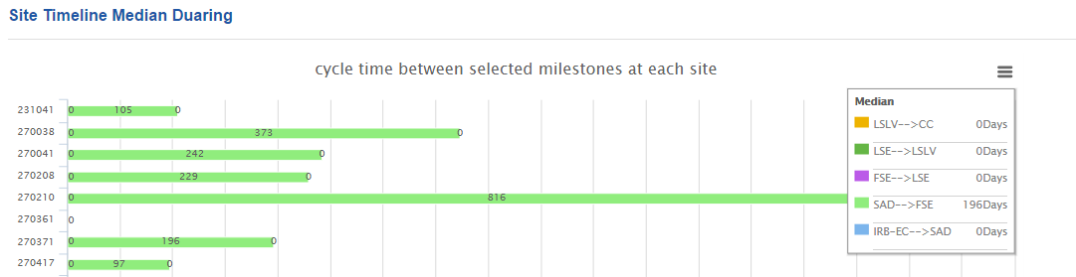

### Recruitment

Display current study of Country level enrollment Progress

Formula:  
% of enrollment (total) = cumulative actual / planned total target * 100  
Enrollment Speed (till the reporting month) = cumulative actual / cumulative planning * 100  
% of low enrollment site = number of low enrollment site / total selected sites * 100  
low enrollment site is site with enrollment speed <=80%

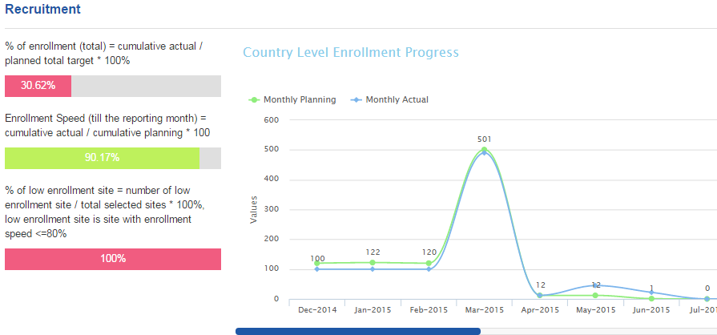

### Issue log

Display current study of % of delayed issues per site (total), and the “Reminder for Coming Due Date” displayed on the right.

Formula: 10 Business days reminder for coming due date

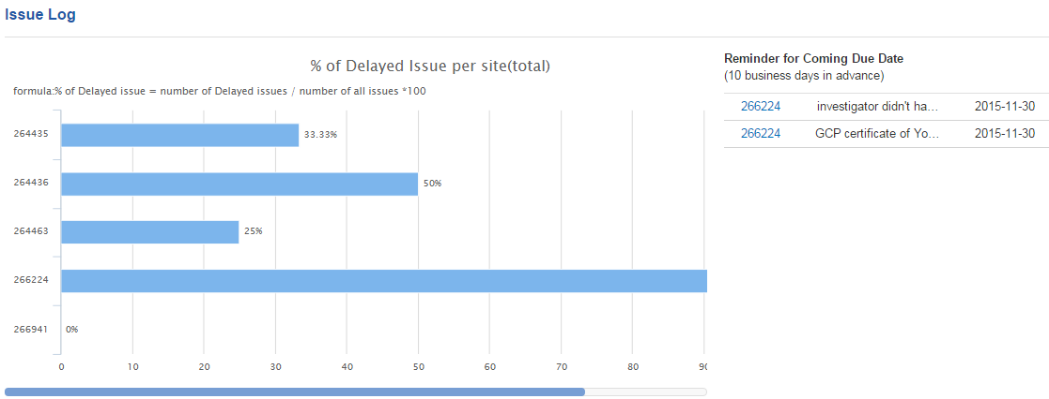

### Trial Monitoring

Display current study of SMR review delayed and % SMR submission delay per month

Formula:  
% of SMR Submission Delay in the reporting month (Date Submitted falls in the reporting month) = number of "Comp. - Sub." >5 / number of submitted SMR *100  
% of SMR Review Delay in the reporting month (Date Reviewed falls in the reporting month) = number of "Sub. - Rev." >5 / number of reviewed SMR * 100

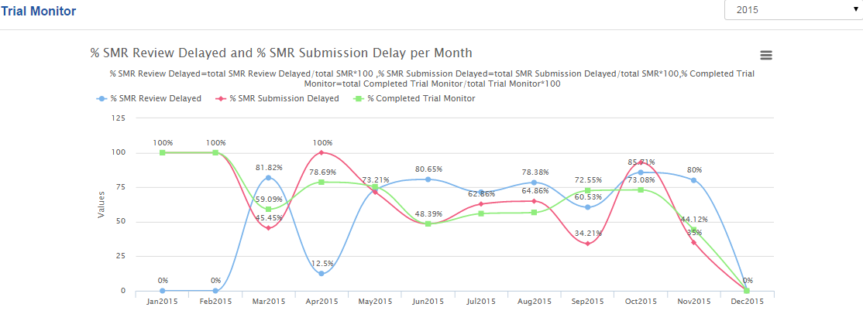

### Safety Reference

Display current study of % of not accessed and % of late received by site

Formula:   
1) % of "Not Accessed" for each site = number of "not accessed" / number of all documents (removed document is excluded).  
2) % of late received for each site = number of late received document / number of all documents, late received means the time between the "date document was first accessed by the site" and "document upload date" is larger than 14 calendar days.

Note: Doc. Rec by Site-Doc. Sub. Date>14

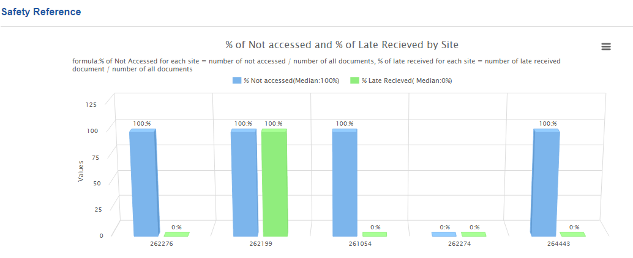

### CRF

Display current study of Missing Data status and Discrepancy status

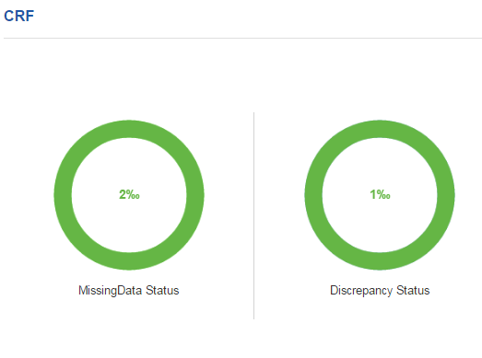

### Site Activation

Display % of correctly activated sites for current study

Formula: % of correctly activated sites = number of correctly activated site / number of total activated site * 100， correctly activated site is site activated with the completion of "site selection checklist" and " green light approval for site activation"

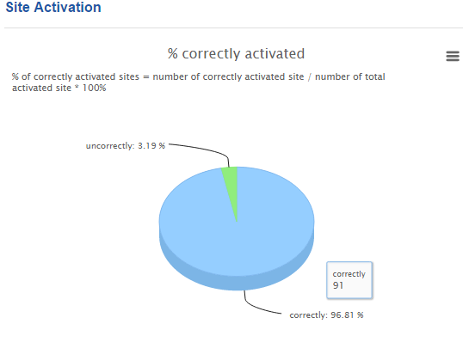

### ICF

Display % correctly approved sites for current study

Formula: % of ICFs which correctly approved for each month, ICF which correctly approved means the "gcp_for004222" is OK status.

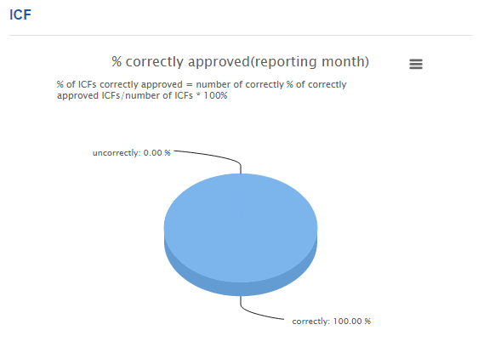

## Time Line

### Country Time Line

Display Country timeline details

Setting: if actual date > planned date, highlight the milestone with red  
Data Analysis: duration days between two consecutive milestones, then get the bar chart

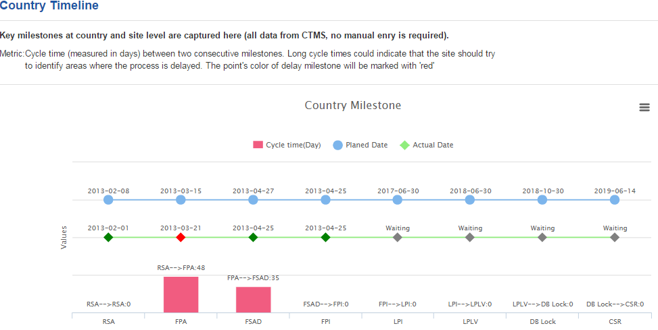

### Site Time Line

1. Display “Median cycle time between selected milestones”
2. Display “Cycle time between selected milestones at each site”
3. Click "Print Picture" button to download chart as different format

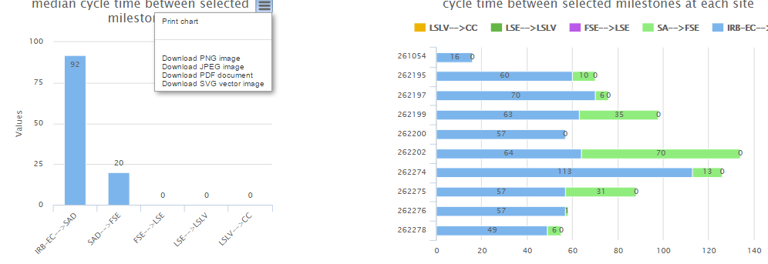

1. Locate filter area to select or search sites.

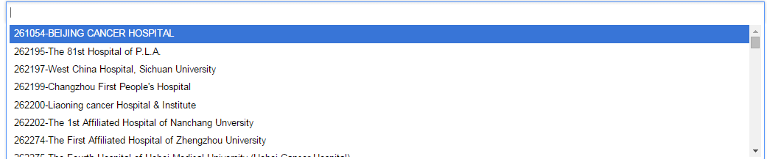

1. Display sites milestone progress.

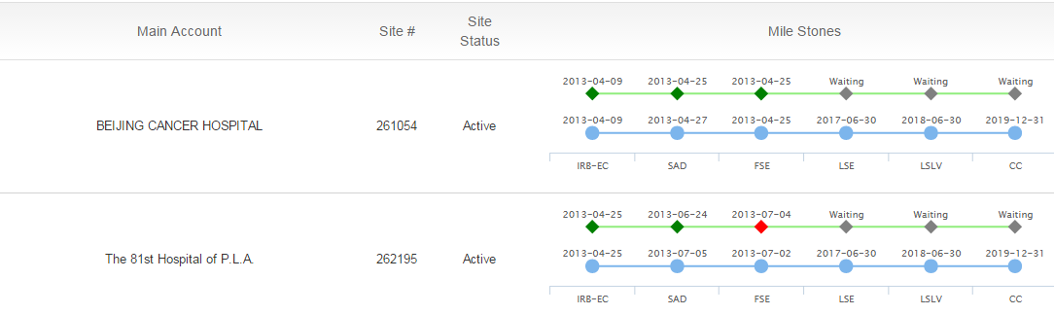

1. Click "Export" to export Time Line, and generate excel file

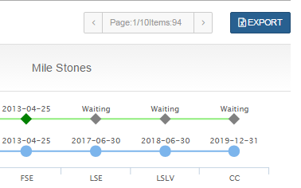

1. CPL can locate downloaded excel for more detailed data.

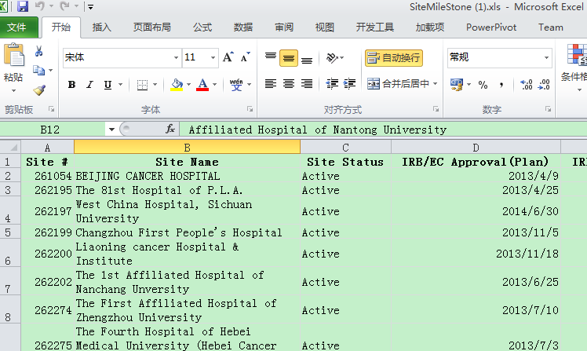

## SMT Chart

CPL can maintain SMT chart

1. Click “Arrow” button on filter area to filter Status/Roles/Company type.



1. Click “Add/Edit” button to add/edit team member, if select "Sponsor or CRO" in Roche/Sponsor/CRO field, please input "Sponsor/CRO" name.
2. If "End" Date is blank, the image highlight as “blue”, if "End" Date is added, the image highlight as “grey”.
3. Click “save” to save changes.



**Note**: IsOwner means backup team member who is also in charge of current study as backup role, by default, the value is “No”. If you want assign a backup member, change the value to “Yes”, and input the “Domain Name” as “RMOASIA\userid”(ex, RMOASIA\GUT2)

1. CPL can click "Export" to export team members, and generate excel file.



1. Open exported excel file to view data.

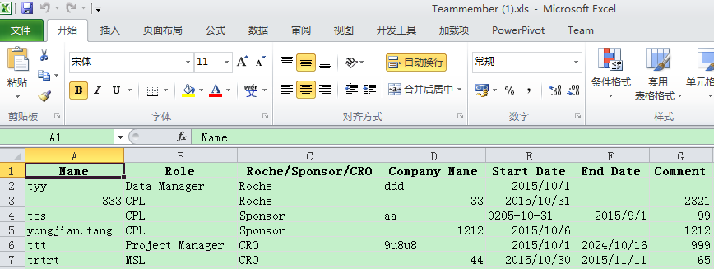

## Issue Log

1. Display “Distribution of issue number per site(total)”

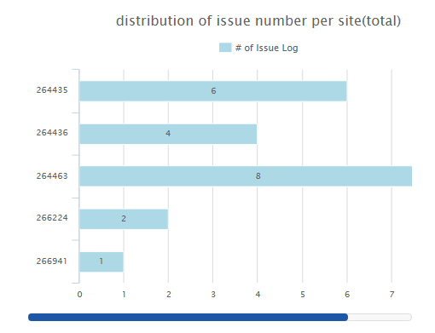

1. Display “Distribution of issue number per type of site(total)”

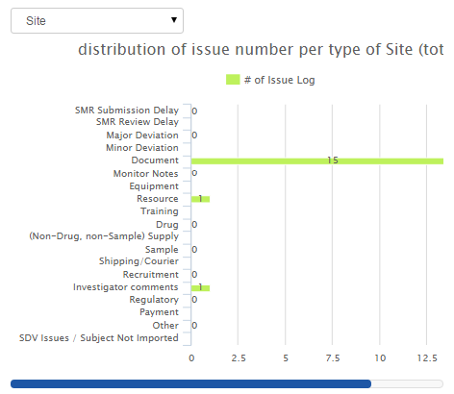

1. Display “Monthly issue log summary”

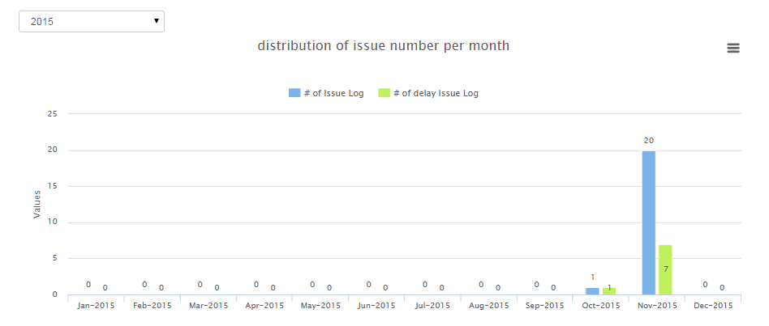

1. Click "Print Picture" button to download chart as different format

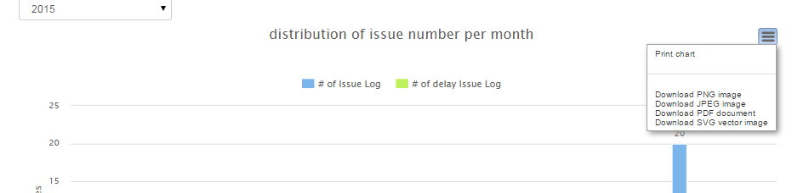

1. Click "Add" button or “Site#” to add/modify issue log, click ok to save changes.
2. Note: when select Site or Subject, the issue type selection list should be changed according to the type.

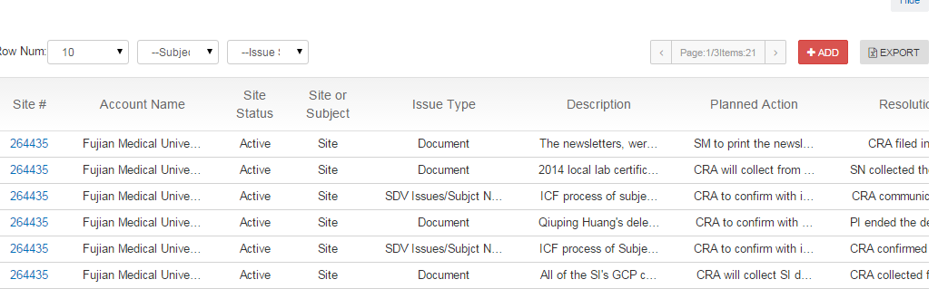

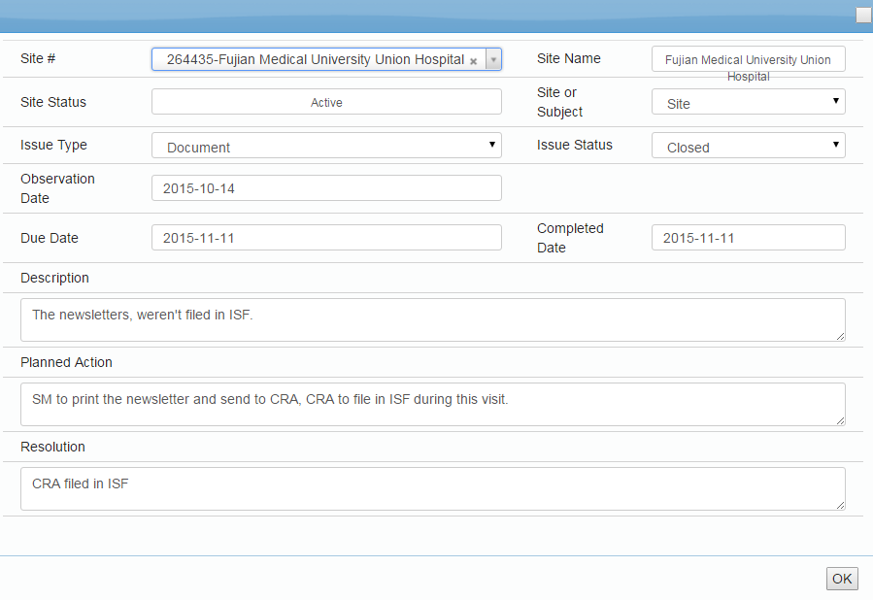

1. Rule Setting in table

Reminder: 10 business days before Due Date, highlight "Due Date" with yellow   
Delay: completed date > due date, highlight the "Completed date" with red

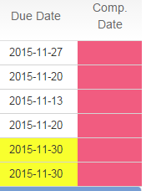

1. Click "Export" to export Issue Log data as excel file



1. Open excel file to view detailed data

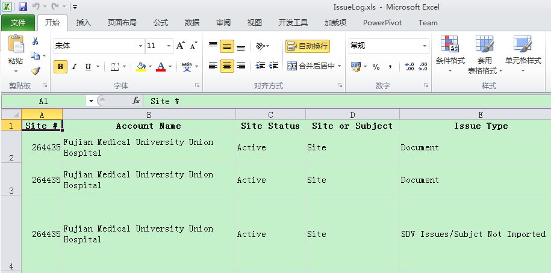

## Case Report Form

Display and maintain monthly CRF completion status.

1. CPL can input current month of discrepancy, missing data, completion value.





Note:   
if # of discrepancy/1000 data points >100, highlight with red   
if # of missing data/1000 data points >200, highlight with red; if >=100 and =<200, amber   
CRF completion percent <= 80%, highlight with red

1. Click save to save record.



1. Click "Export" to export Case Report Form data as excel file



1. Open excel file to check CRF data.

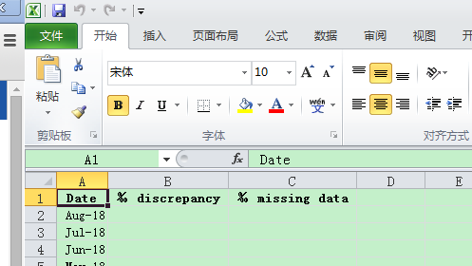

## Trial Monitoring

Display “Trial Monitoring per site”, “maintain On-site Monitoring Frequency”, “maintain Trial Monitoring data table”.

1. Display Trial Monitoring per site.

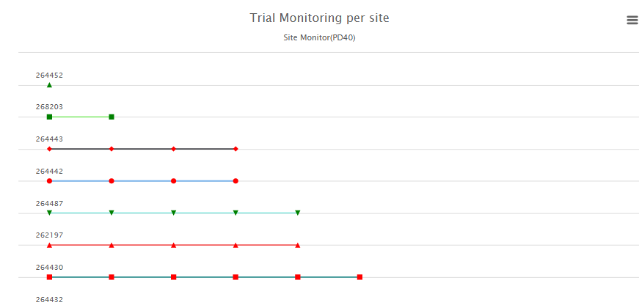

Formula: Green in chart: Activity Start Date of PD40 in the range of Earliest Trial Date and Latest Trial Date  
Red in chart: Activity Start Date of PD40 out the range of Earliest Trial Date and Latest Trial Date

1. Maintain “On-site Monitoring Frequency” , manually input frequency, click save to save records, then click generate plan to update Earliest Trial Date and Latest Trial Date.

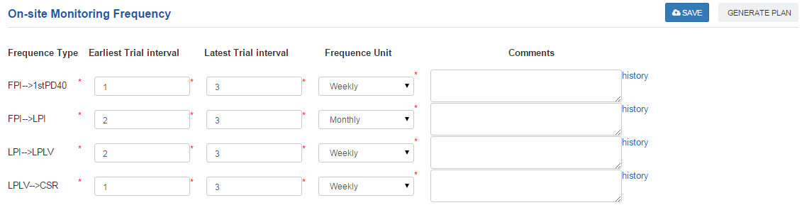

1. In the table, manually maintain “CPL confirm”, and “CPL comments”,” Monitor comments” , click save to save changes.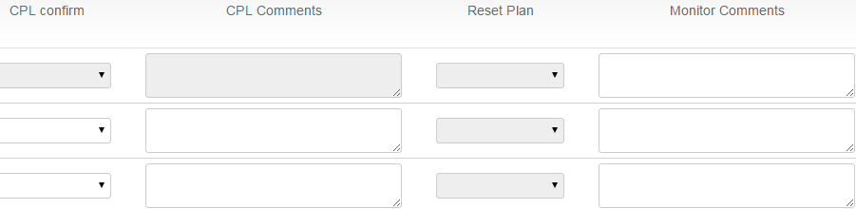
2. Check traffic light in data table.

Formula: if Comp-Sub(SubmitedDate-ACD)/Sub.-Rev(DateReviewed-SubmitedDate)  
>10, red; 10>= and >5, yellow.

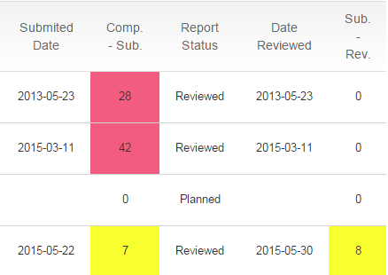

1. Click "Export" to export Case Report Form data as excel file



1. Open excel file to check data.

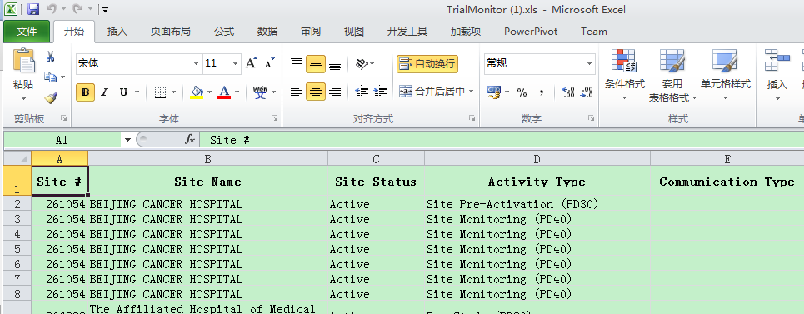

## Site Activation

Maintain site activation records.

1. Locate a record, and click on drop down arrow for SSC or GLA, change its status, click save to save change.

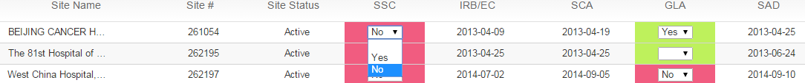



Note:

Setting: If ("Site Selection Checklist"="No" and "IRB/EC approval" is not blank/-), alert "Site Selection Checklist (SSC)" is red.

If ("Green Light Approval="No" and "site activation date" is not blank/-), alert "Green Light Approval (GLC)" is red.

1. Click "Export" to export team members, and generate excel file.



1. Open excel file to view data.

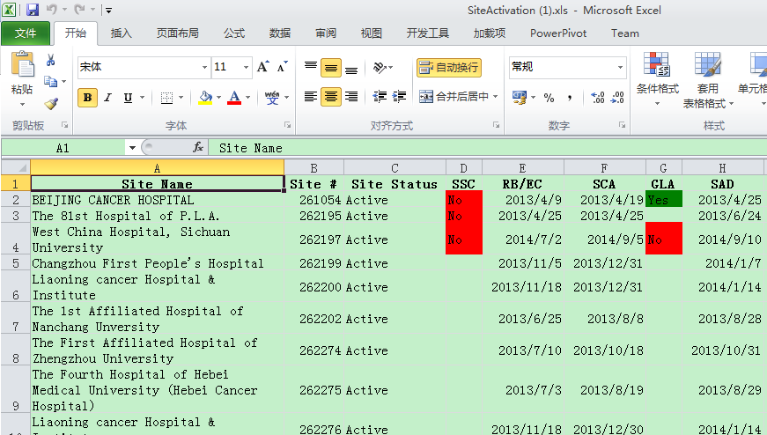

## Safety Reference

Display “% of Not accessed and % of late received by site”, and maintain Safety Reference records.

1. Display “% of Not accessed and % of late received by site”.

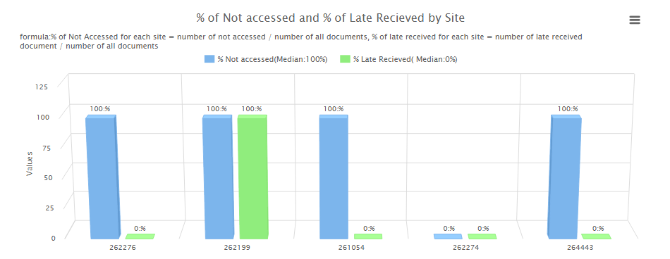

1. Click "Print Picture" button to test download chart as different format.

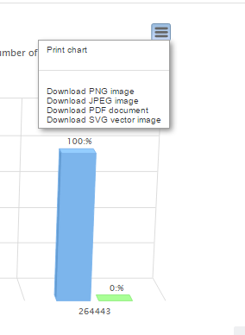

1. Click "Add" or “Edit” button to add/edit a site record, click "Save" to save record

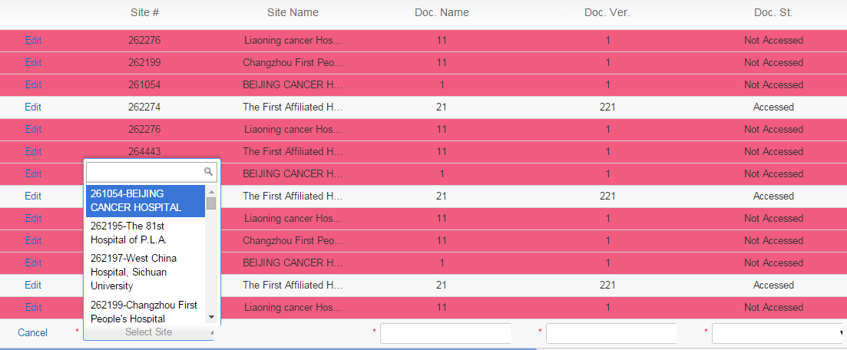

Note: Setting: If "Document Status" = "Not Accessed", highlight with red

1. Use filter areas to filter sites, for example, click on "-Status-".

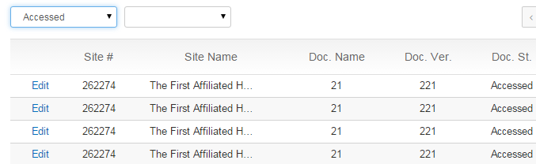

1. Click "Export" to export Safety Reference data, and generate excel file



1. Open excel file to view data.

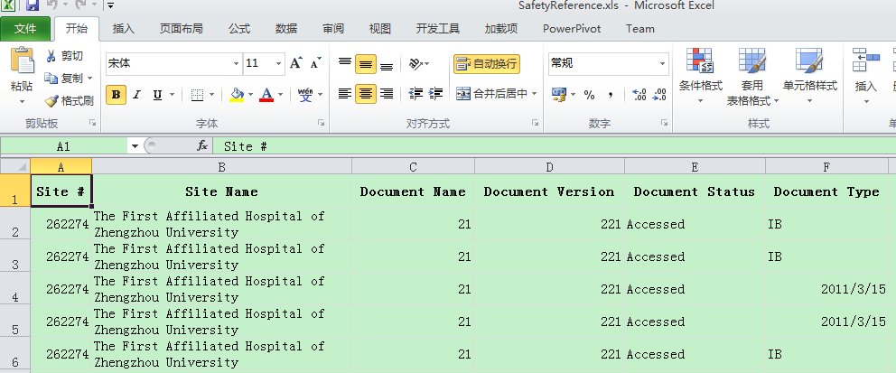

1. CPL can modify more than one records through downloaded excel file, after update records in excel, click “IMPORT” button, choose excel file, click “upload”, click “ok”.



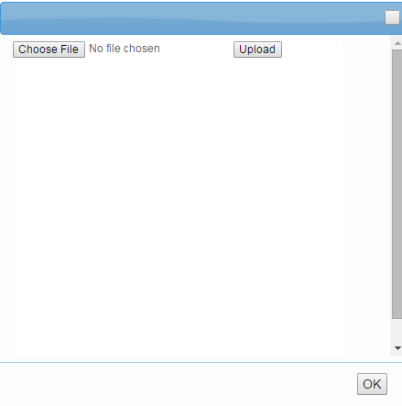

## ICF

Display “ICF Summary(Country)”, “ICF Summary(Site)”, and maintain ICF records.

1. Display “ICF Summary(Country)”

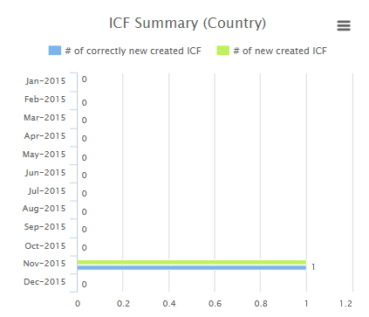

1. Display “ICF Summary(Site)”

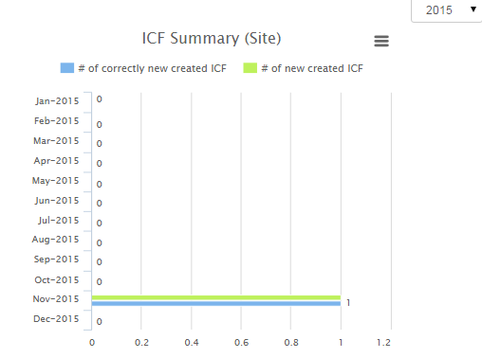

1. Click "Print Picture" button to test download chart as different format

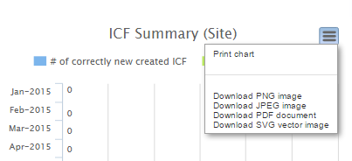

1. Use filter area to filter sites.

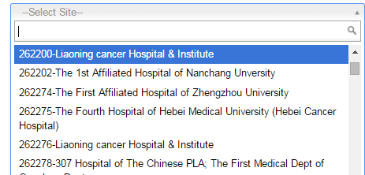

1. Click on "Add" or “Edit” button to add or edit a record





1. Click on dropdown button for “Country/Site”, and select either Country or Site; Click on dropdown button for “Doc. Rev. & Appr. Form”, select OK/No.; Input information in "Version" & "Version Date" fields.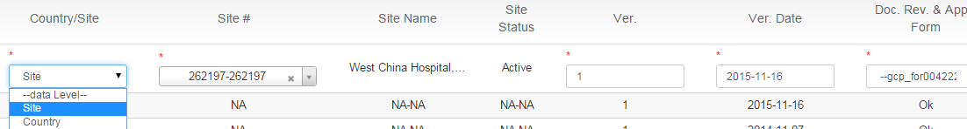
2. Click “Save” to save record.
3. Click "Export" to export ICF data, and generate excel file.



1. Open excel file to view data.

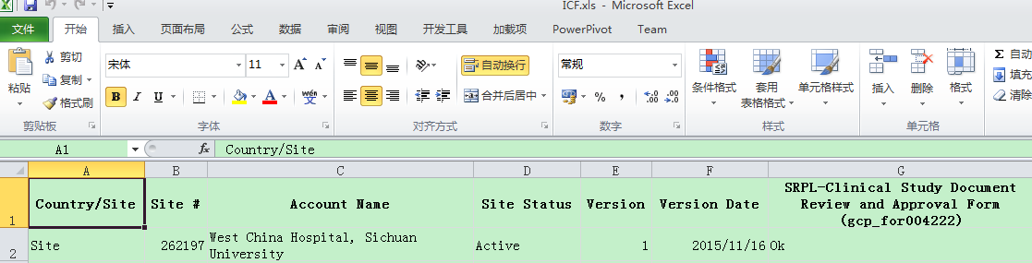

## Recruitment

### Country Recruitment

Display “Country Level Enrollment Progress” for current study, and maintain recruitment record.

1. Display "Country Level Enrollment Progress"

Formula: Enrollment Speed (till the reporting month) = cumulative actual / cumulative planning * 100%

Enrollment Speed(till the reporting month) , (total) % of Enrollment = cumulative actual/planned # enrolled (total target)*100%

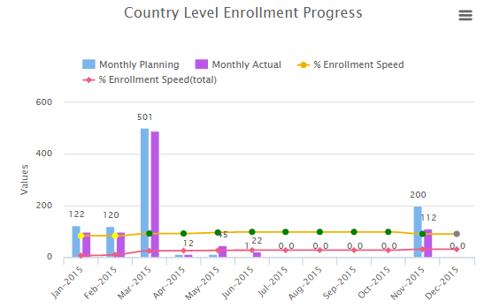

1. Click "Print Picture" button to download chart as different format.

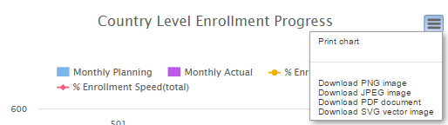

1. Display Revised Planned # Enrolled, First Subject Enrolled (FPI),Last Subject Enrolled (FPI),Calculated Planned # Enrolled

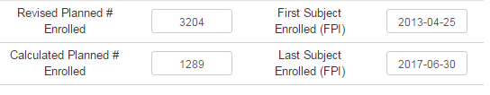

1. Maintain monthly recruitment record, and clicks save to save record.

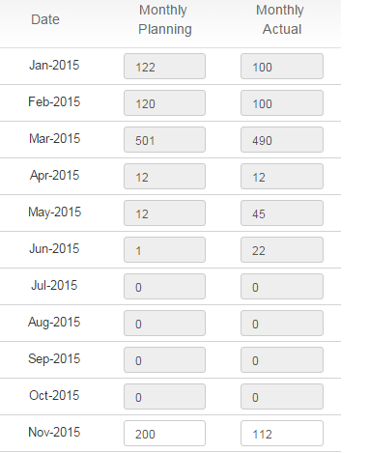

1. Click "Export" to export Country Recruitment data, and generate excel file



1. Open excel file to view data

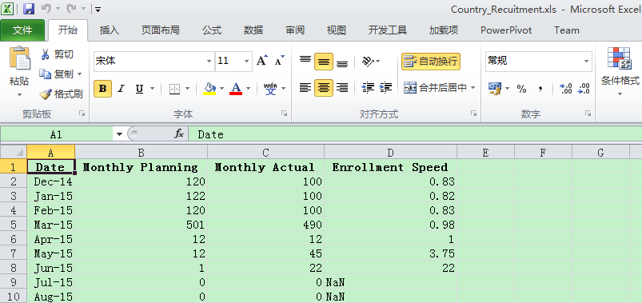

### Site Recruitment

Display “Site Enroll Summary”, maintain site recruitment record

1. Display “Site Enroll Summary”

Formula:

Enrollment Speed (till the reporting month) = cumulative actual / cumulative planning * 100%  
Enrollment Speed (till the reporting month) , (total) % of Enrollment = cumulative actual/planned # enrolled (total target)*100%

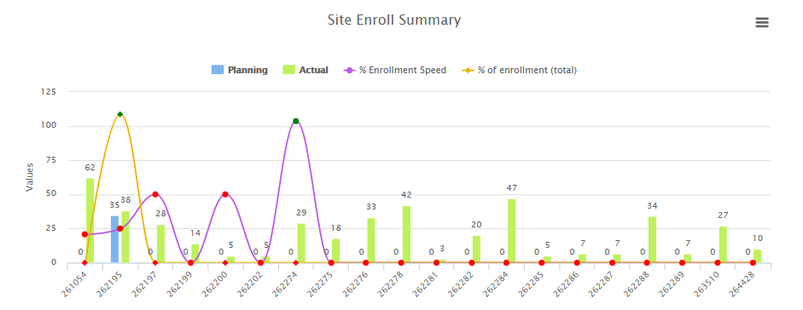

1. Click "Print Picture" button to download chart as different format

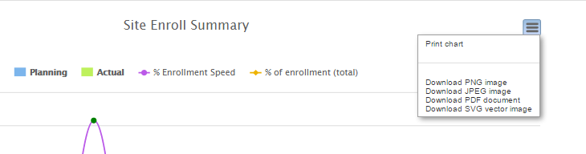

1. In the site recruitment table, manually input “planning”, “actual”, and click save to save record.



1. Click on Site Num in table to check detailed information.

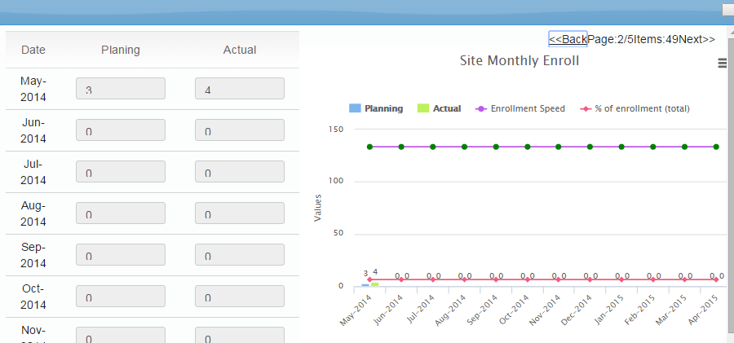

1. Click "Export" to export Site Recruitment data, and generate excel file.



1. Open excel file to view data.

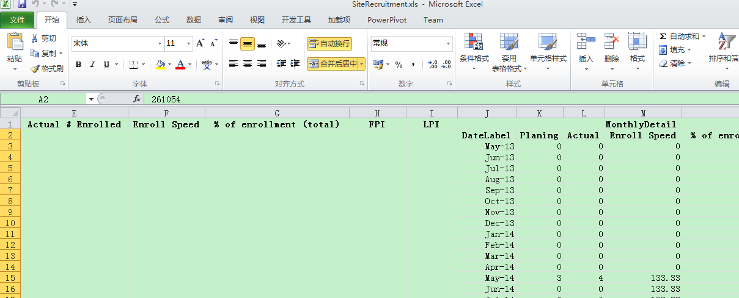

# Operation: LM

LM (Line Manager) can only view all China studies information, and detailed study information, but do not have permission to maintain study details.

## Access Home Page

On Home Page, Line Manager can see all on-going studies of China.

http://spdeweb01.shp.roche.com/sites/StudyPortal/SitePages/HomePage.aspx

### Milestone Summary by Study

Display duration between two consecutive Milestones



### Monthly Step Count/ Median Step During

1. Planning count (Reporting Month), Actual count (Reporting Month), Ahead count(YTD) is counts of Actual date < Planned date at each milestone level.



1. Click on arrow to view Median Step During, which means the median duration days between two consecutive milestones.



### Study Milestone details

Display Study Milestone details, If Actual date <= Planned date, marked in green, If Actual date > Planned date, marked in red.



### Study Summary by Status

Display counts of Study by different status and priority.



### Study Summary by GPS

Display counts of Study by GPS.



### Study Summary by DA

Display counts of Study by DA.



### Study Summary by Interventional

Display counts of Study by Interventional.



### Site Activation

Display % of correctly activated sites per month.

Formula: Corrected active sites/total activated sites



### Recruitment

Display Enrollment Speed by Study

Formula:

% enrollment speed: Cumulative Actual/Cumulative Planning

% enrollment (total):SCNTR_ACTUALNUMENROLLED/PLANNEDNUMENROLLED

% low enrollment site: Low percent counts of site /Total counts



### ICF

Display % of correctly approved ICFs

Formula: Correctly approved ICFs/total ICFs



### Issue Log

Display % of delayed issues per month

Formula: Delayed issues/Total issues



### Trial Monitor

Display % SMR submission delayed and % SMR review delayed per month

Formula: SMRReviewDelay=DelaySToRCount/TotalCount

SMRSubmissiondelay=DelayCToSCount/TotalCount



### CRF

Display # missing data/1000(reporting month), # discrepancy data/1000(reporting month), CRF completion %



### Safety Reference

Display % of late received and % of not accessed per month

Formula: 1) % of "Not Accessed" for each site = number of "not accessed" / number of all documents (removed document is excluded).

2) % of late received for each site = number of late received document / number of all documents, late received means the time between the "date document was first accessed by the site" and "document upload date" is larger than 14 calendar days.



## Overview Page

Overview page display single detailed study information, Line Manager can check /uncheck filter to display relevant information.



### General information

Display General Information for current study.

### Country Timeline

Display current study of Country Milestone

Formula:   
Cycle Time=duration days between two consecutive milestones, If actual date > planned date, highlight the milestone with red.



### Site Timeline Median Duration

Display current study of Cycle time between selected milestones at each site.

Formula:

Duration days between two consecutive milestones



### Recruitment

Display current study of Country level enrollment Progress

Formula:  
% of enrollment (total) = cumulative actual / planned total target * 100  
Enrollment Speed (till the reporting month) = cumulative actual / cumulative planning * 100  
% of low enrollment site = number of low enrollment site / total selected sites * 100  
low enrollment site is site with enrollment speed <=80%



### Issue log

Display current study of % of delayed issues per site (total), and the “Reminder for Coming Due Date” displayed on the right.

Formula: 10 Business days reminder for coming due date



### Trial Monitoring

Display current study of SMR review delayed and % SMR submission delay per month

Formula:  
% of SMR Submission Delay in the reporting month (Date Submitted falls in the reporting month) = number of "Comp. - Sub." >5 / number of submitted SMR *100  
% of SMR Review Delay in the reporting month (Date Reviewed falls in the reporting month) = number of "Sub. - Rev." >5 / number of reviewed SMR * 100



### Safety Reference

Display current study of % of not accessed and % of late received by site

Formula:   
1) % of "Not Accessed" for each site = number of "not accessed" / number of all documents (removed document is excluded).  
2) % of late received for each site = number of late received document / number of all documents, late received means the time between the "date document was first accessed by the site" and "document upload date" is larger than 14 calendar days.

Note: Doc. Rec by Site-Doc. Sub. Date>14



### CRF

Display current study of Missing Data status and Discrepancy status



### Site Activation

Display % of correctly activated sites for current study

Formula: % of correctly activated sites = number of correctly activated site / number of total activated site * 100， correctly activated site is site activated with the completion of "site selection checklist" and " green light approval for site activation"



### ICF

Display % correctly approved sites for current study

Formula: % of ICFs which correctly approved for each month, ICF which correctly approved means the "gcp_for004222" is OK status.



## Time Line

### Country Time Line

Display Country milestone, duration days between two consecutive milestones,

Setting: if actual date > planned date, highlight the milestone with red



### Site Time Line

1. Display “Median cycle time between selected milestones”
2. Display “Cycle time between selected milestones at each site”
3. Click "Print Picture" button to download chart as different format



1. Locate filter area to select or search sites.



1. Display sites milestone progress.



1. Click "Export" to export Time Line, and generate excel file



1. Locate and open downloaded excel for more detailed data.



## SMT Chart

1. View SMT Chart in detailed.

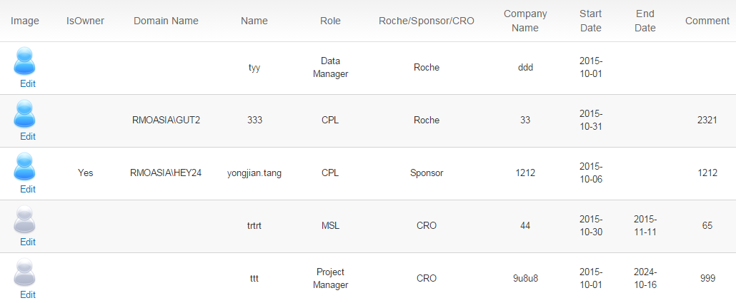

1. Click “Arrow” button on filter area to filter Status/Roles/Company type.



1. If "End" Date is blank, the image highlight as “blue”, if "End" Date is added, the image highlight as “grey”.



**Note**: IsOwner means backup team member who is also in charge of current study as backup role, by default, the value is “No”. If CPL assigned a backup member, the value is “Yes”, and the “Domain Name” is Roche User ID (ex, GUT2)

1. Click "Export" to export team members, and generate excel file.

## Issue Log

1. Display “Distribution of issue number per site(total)”



1. Display “Distribution of issue number per type of site(total)”



1. Display “Monthly issue log summary”



1. Click "Print Picture" button to download chart as different format



1. Check issue log records table for more details.





1. Rule Setting in table

Reminder: 10 business days before Due Date, highlight "Due Date" with yellow   
Delay: completed date > due date, highlight the "Completed date" with red



1. Click "Export" to export Issue Log data as excel file



1. Open excel file to view detailed data



## Case Report Form

1. View CRF chart in detailed





Note:   
if # of discrepancy/1000 data points >100, highlight with red   
if # of missing data/1000 data points >200, highlight with red; if >=100 and =<200, amber   
CRF completion percent <= 80%, highlight with red

1. Click "Export" to export Case Report Form data as excel file



1. Open excel file to check CRF data.



## Trial Monitoring

1. View Trial Monitoring per site.



Formula: Green in chart: Activity Start Date of PD40 in the range of Earliest Trial Date and Latest Trial Date  
Red in chart: Activity Start Date of PD40 out the range of Earliest Trial Date and Latest Trial Date

1. View “On-site Monitoring Frequency” 
2. View Trial Monitoring details.

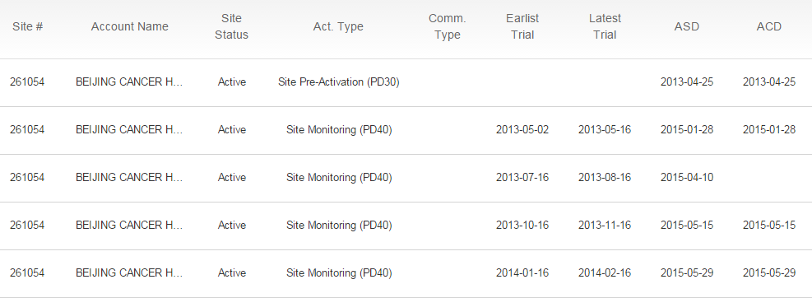

1. Check traffic light in data table.

Formula: if Comp-Sub(SubmitedDate-ACD)/Sub.-Rev(DateReviewed-SubmitedDate)  
>10, red; 10>= and >5, yellow.



1. Click "Export" to export Case Report Form data as excel file



1. Open excel file to check data.



## Site Activation

1. View Site Activation details.

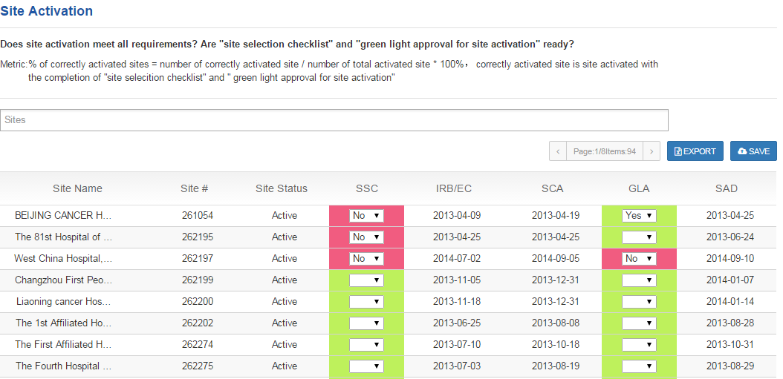

Note:

Setting: If ("Site Selection Checklist"="No" and "IRB/EC approval" is not blank/-), alert "Site Selection Checklist (SSC)" is red.

If ("Green Light Approval="No" and "site activation date" is not blank/-), alert "Green Light Approval (GLC)" is red.

1. Click "Export" to export team members, and generate excel file.



1. Open excel file to view data.



## Safety Reference

1. View “% of Not accessed and % of late received by site”.



1. Click "Print Picture" button to test download chart as different format.



1. View Safety Reference table in detailed.

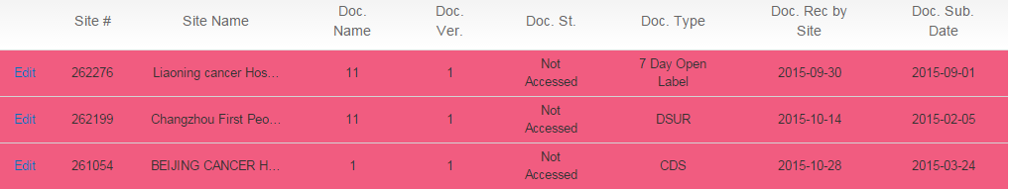

Note: Setting: If "Document Status" = "Not Accessed", highlight with red

1. Use filter area to filter sites.



1. Click "Export" to export Safety Reference data, and generate excel file



1. Open excel file to view data.



## ICF

1. View “ICF Summary(Country)”



1. View “ICF Summary(Site)”



1. Click "Print Picture" button to test download chart as different format



1. Use filter area to filter sites.



1. View ICF table in detailed.

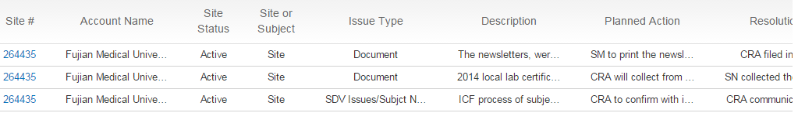

1. Click "Export" to export ICF data, and generate excel file.



1. Open excel file to view data.



## Recruitment

### Country Recruitment

1. View "Country Level Enrollment Progress"

Formula: Enrollment Speed (till the reporting month) = cumulative actual / cumulative planning * 100%

Enrollment Speed(till the reporting month) , (total) % of Enrollment = cumulative actual/planned # enrolled (total target)*100%



1. Click "Print Picture" button to download chart as different format.



1. Display Revised Planned # Enrolled, First Subject Enrolled (FPI),Last Subject Enrolled (FPI),Calculated Planned # Enrolled



1. View monthly recruitment record, and clicks save to save record.



1. Click "Export" to export Country Recruitment data, and generate excel file



1. Open excel file to view data



### Site Recruitment

1. View “Site Enroll Summary”

Formula:

Enrollment Speed (till the reporting month) = cumulative actual / cumulative planning * 100%  
Enrollment Speed (till the reporting month) , (total) % of Enrollment = cumulative actual/planned # enrolled (total target)*100%



1. Click "Print Picture" button to download chart as different format



1. View site recruitment records in detailed



1. Click on Site Num in table to check detailed information.



1. Click "Export" to export Site Recruitment data, and generate excel file.



1. Open excel file to view data.

